Natural Language Processing (NLP)

Contents

Why NLP? 3

Current limitation of NLP 4

Roadmap of NLP 4

Basic Terminology used in NLP 5

Preprocessing of text data 5

Tokenization 5

Stop words 6

Stemming 6

Lemmatization 7

Lowering the case of Words 7

Converting Text to vector 8

One Hot Encoding 8

Bag of Words (BOW) 9

Capturing semantic Information using Ngrams 12

TF-IDF (Term Frequency - Inverse Document Frequency) 13

# Why NLP?

* Content recommendation like news ads based on profile and interest.
* Sentiment analysis
* Prediction of next text for Generative AI
* Text summarization, language translation
* Spam classification
* chatbot

NLP can be used both machine learning and deep learning. At the end of the day we are creating a AI application.

We will see how words can be converted to vector how machine is able to understand text and give output.

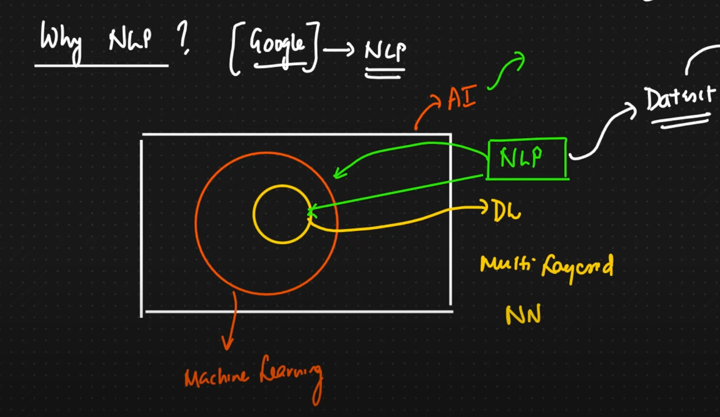

Example: Say we are searching in google as ram temple

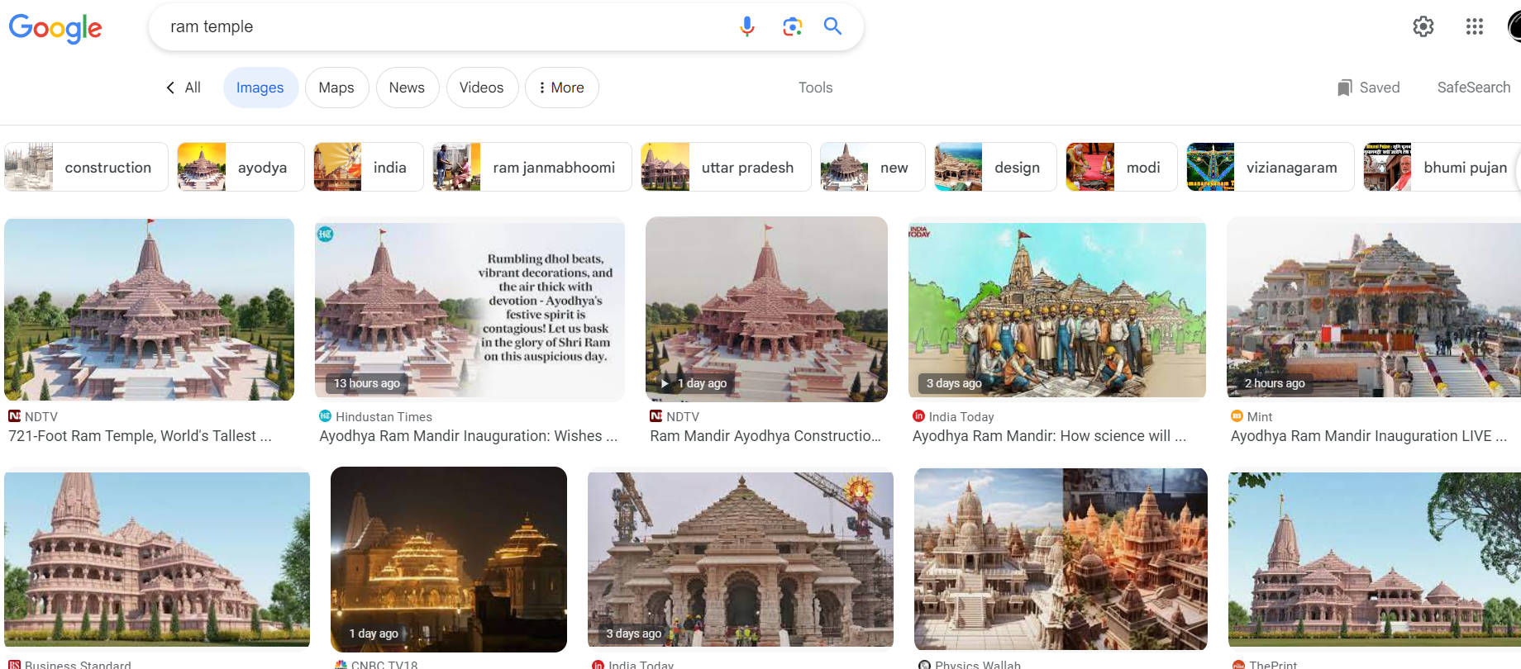

Now how all the images are associated with these images mean in the background text to image conversion is happening that might be using NLP.

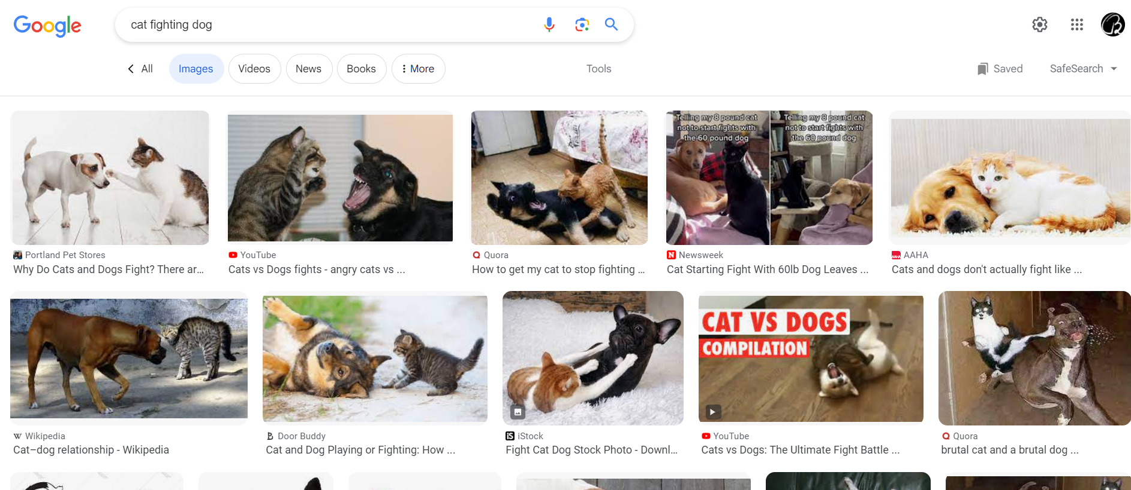

# Current limitation of NLP

NLP not able to understand sarcasm in text. Machine is not able to understand sarcasm properly, so research is going on.

# Roadmap of NLP

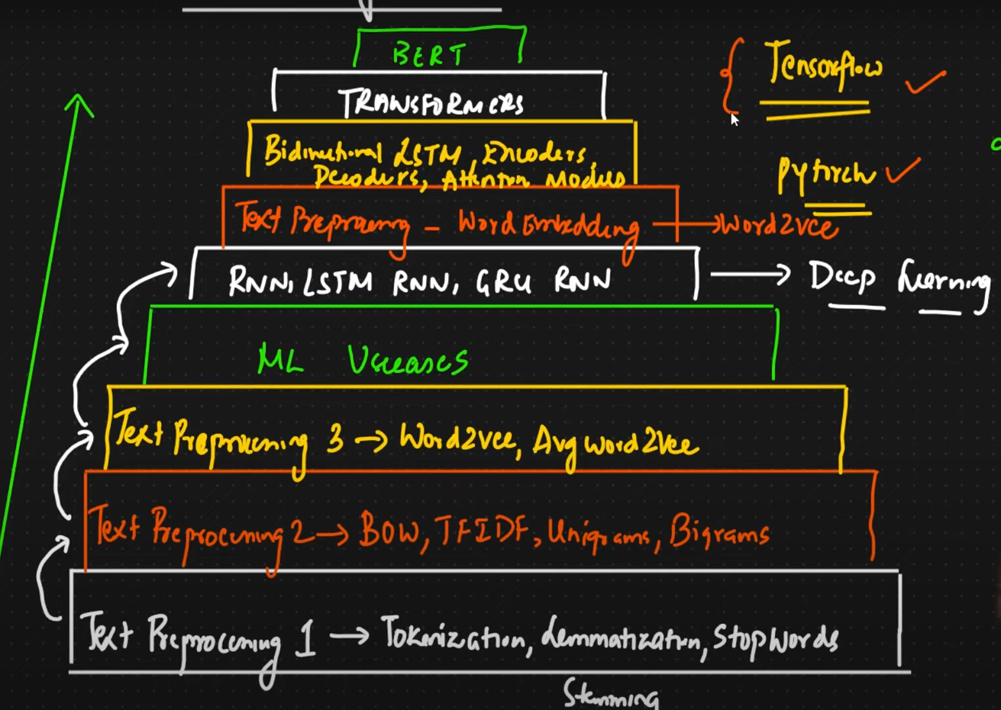

# Basic Terminology used in NLP

1. CORPUS
2. Documents
3. Vocabulary
4. Words

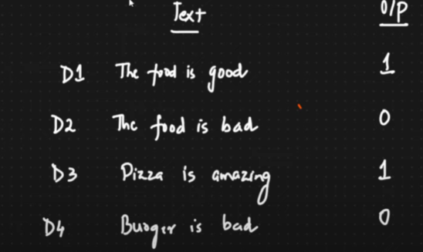

**CORPUS**: It’s like a **paragraph** like entire data set if we club together. Say my CORPUS is [D1,D2,D3,D4]

**Document**: Each **sentence** in the paragraph can b called as Document in NLP like D1 D2 etc. Though it is just a sentence but for NLP it is document. e.g. The food is good => D1

**Vocabulary**: It is the collection of all **unique** **words** in the CORPUS.

Say in my CORPUS we have 10K unique words in this case my vocabulary will be

**The, food, is, good, bad, Pizza, Amazing, Burger**

**Words**: All words in the CORPUS.

# Preprocessing of text data

We need to do preprocessing of raw text before using it for NLP we will be using **NLTK** (Natural Language Toolkit) libraries for doing pre-processing. Here is the way we can do,

Code Link: <https://github.com/gourabb8273/ML-Model-HandsOn-Hub/tree/master/NLP/Practicle/Pre-processing>

## Tokenization

Say we are using spam classifier. Our data set will be like

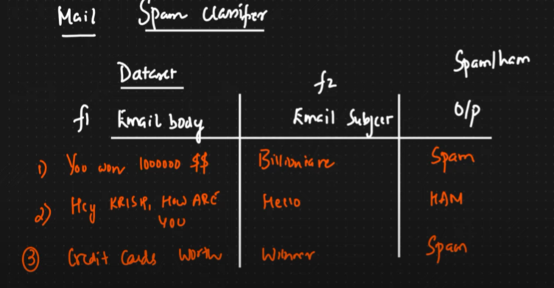

The first step here would be tokenization. It’s about converting sentence into word so that those should be understandable by machine learning algorithm.

Sentence: You won 1000000 $$ after tokenization it will be



## Stop words

Next step is stop words. Say we have a sentence like

“Hey buddy I want to go to your house” here we can see some words like **to** are not making any sense in prediction so we can remove those words.

Example of stop words: to, he she, is for of etc.

To remove all these words which are insignificant in output prediction using stop words. We can create our own custom stop words list as well. However we may need this in text summarization but not needed for spam classification or sentiment prediction.

## Stemming

Here if we have say many similar types of words in different form we can convert those in base or root word thus we can reduce the number of words. It’s a process of reducing words to the base word.

But base word may or may not have any meaning.

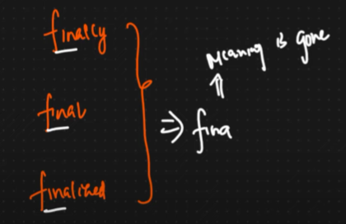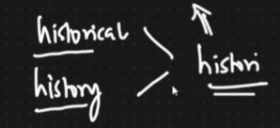

**Advantage**: It’s very fast can be applied on large dataset

**Disadvantages**: It is removing the meaning of the word

**Use cases:**

* Spam classification
* Review classification

To overcome it we have lemmatization.

## Lemmatization

It has entire dictionary of words it will work the same way like stemming but it will give meaningful word.

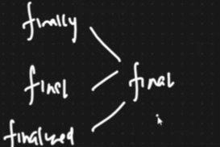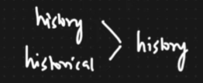

**Advantage**: We will be able to get meaningful word.

**Disadvantages**: It is slow as it has to do lots of comparison.

**Use cases:**

* Text summarization
* Language translation
* Chatbot

## Lowering the case of Words

We will be now lowering the case of all word.

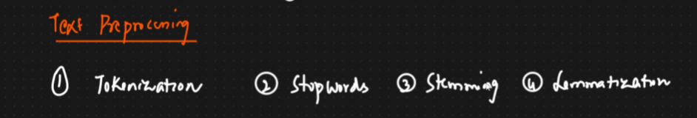

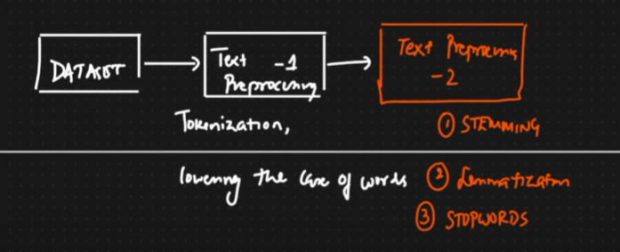

## Converting Text to vector

In the next step we will be converting words to vector using different techniques,

1. OHE (One Hot Encoding)
2. Bag of words (BOW)
3. TF-IDF (Term Frequency Inverse Document Frequency)
4. WordtoVec

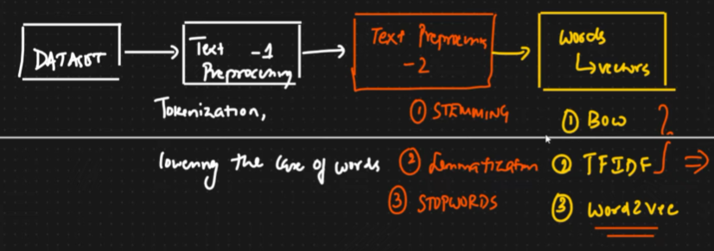

### One Hot Encoding

Say my CORPUS is

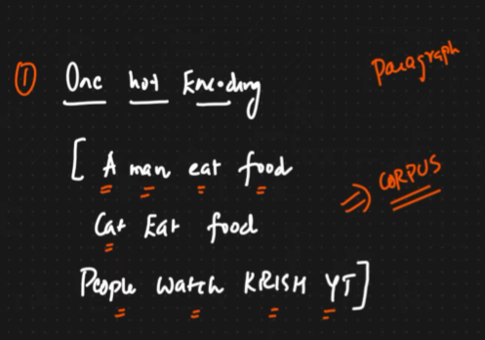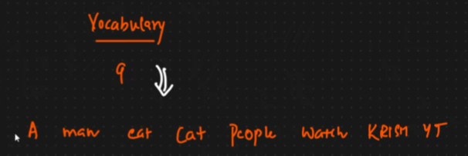

Now each word will be represented as one hot encoding. After doing this we will get as follows

For first document D1 – **A man eat food** we will get.

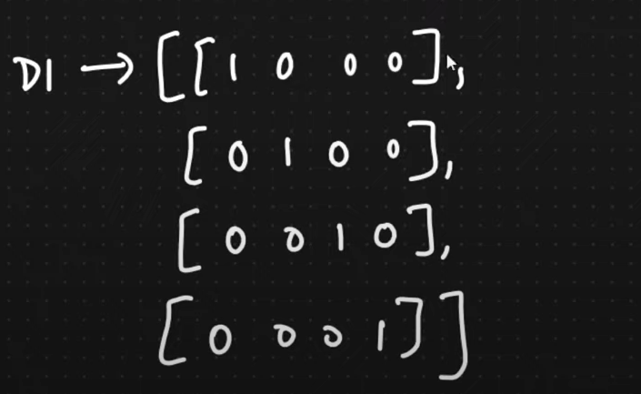

Here we have 4 words

For the second document D2 – **Cat Eat Food** we will get.

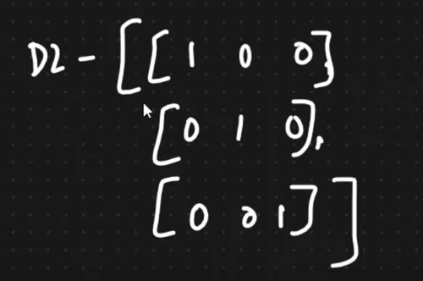

Here we have only 3 words so if vocabulary size is decreases then we can’t train the model. Input feature should be fixed constant this called out of vocabulary.

**Advantage**:

* Simple to implement.
* Intuitive

**Disadvantage**

* For large set of vocabular size of sparse (many zero values) matrix will be large difficult to compute
* OOV (Out of vocabulary), my sentence is not fixed size. Any new extra words if we get can’t be handled.
* Between the word semantic meaning is not captured like how two words related as each row only one column is 1 rest zero.

### Bag of Words (BOW)

It is a technique of converting **text to vector**. Say my CORPUS is as follows,

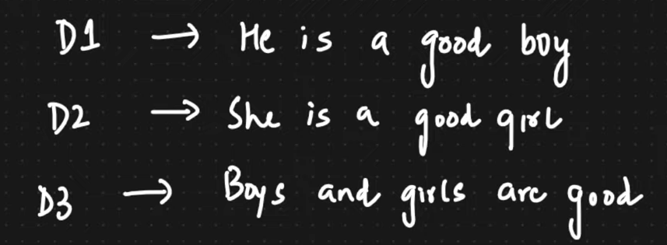

Now we will use stop words and remove unnecessary words also will lower all case.

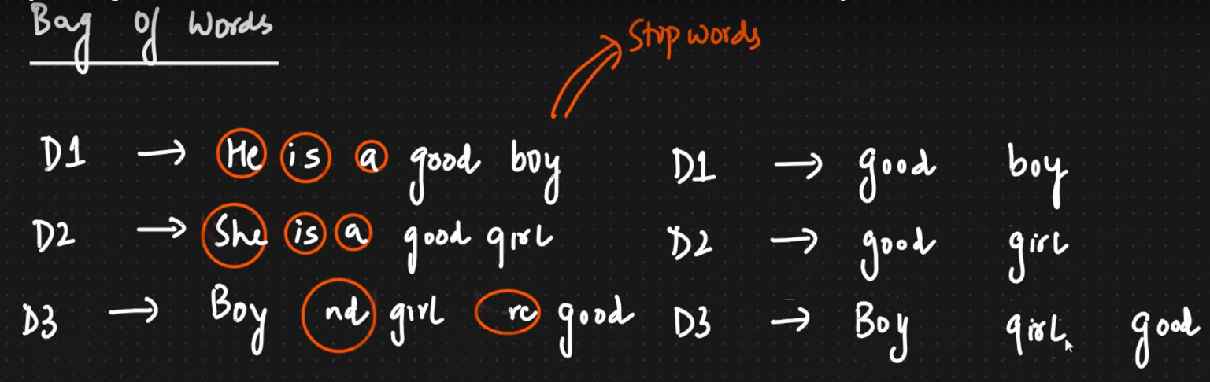

Now my vocabulary unique words will be my feature. Let’s see that with frequency like no of time words are repeating,

Order of the feature will be based on frequency e.g. if **good** is repeating more time than other then first feature f1 will be **good**.

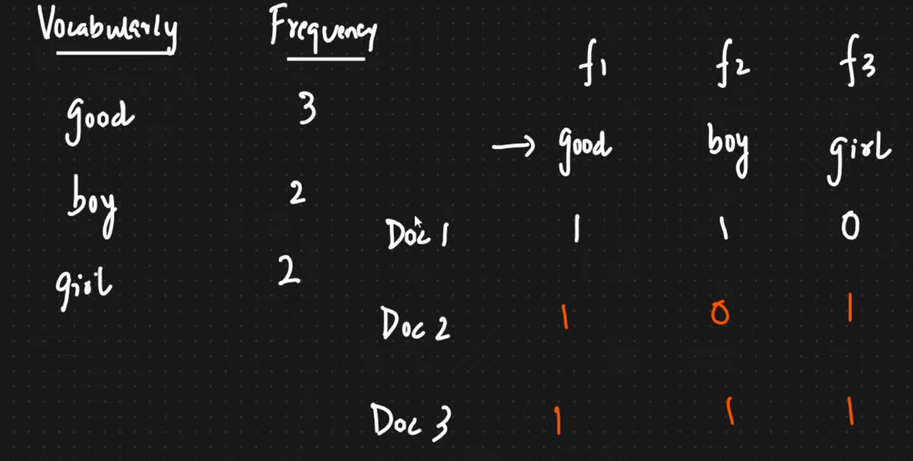

We will just increase the count in the feature based on the document. Like first doc was good boy so f1 and f2 became 1 and f3 is 0.

Say in Document 1 we have one more good like – **good boy good** then count of **f1** will be increased by 2.

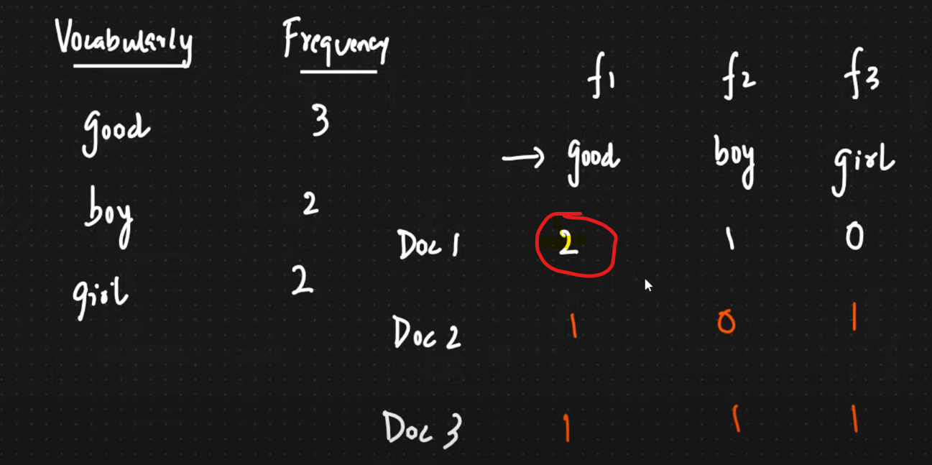

**Binary Bag of Words:** In Bag of Word there is an option called **Binary Bag of Words**. Like if any count more than 1like f1 then also we will make it 1.

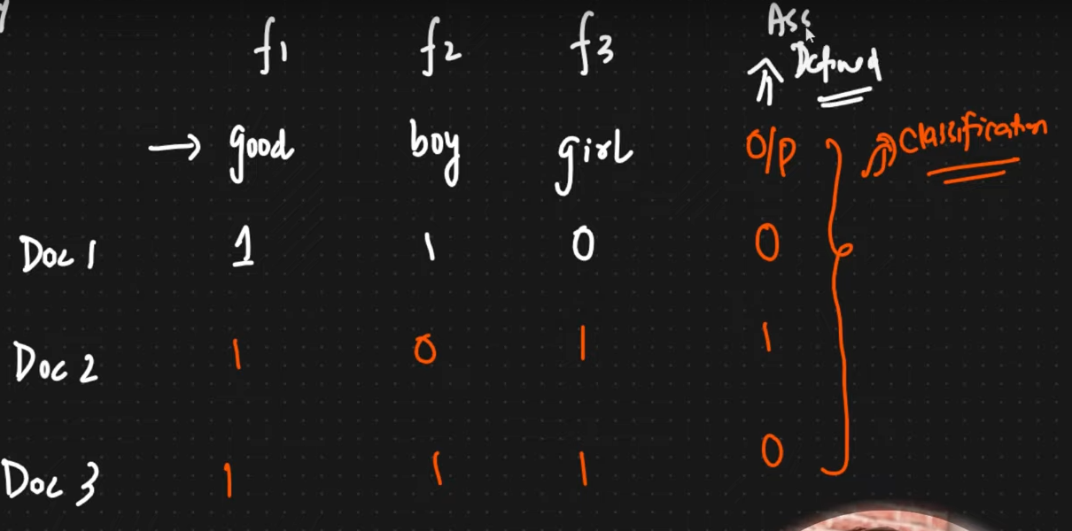

**Advantage**:

* Simple and Intuitive

**Disadvantage**

* Sparsity is still there though improved but not fixed.
* OOV (Out of vocabulary), if we get any new word like say **cat** then we won’t be able to handle in feature so entire word will get rejected so meaning will get changed.
* Ordering of the word completely changed as we are doing ordering based on max frequency so won’t be able to make semantic relationship.

If we take those features of 3 dimensions and plot it we will be able to calculate distance between them to find the similarity

* Euclidian Distance
* Cosine Similarity

**Cosine Similarity**

Say we have two point and we need to find out the similarity we will find the angle between them and subtract from 1. So P1 and P2 is 47% similar.

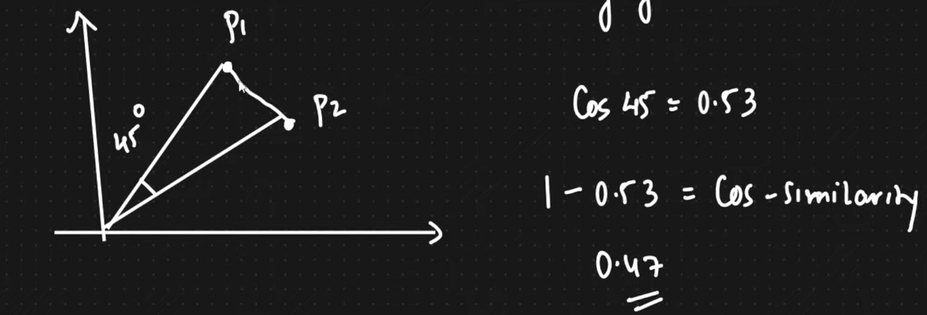

Say another example,

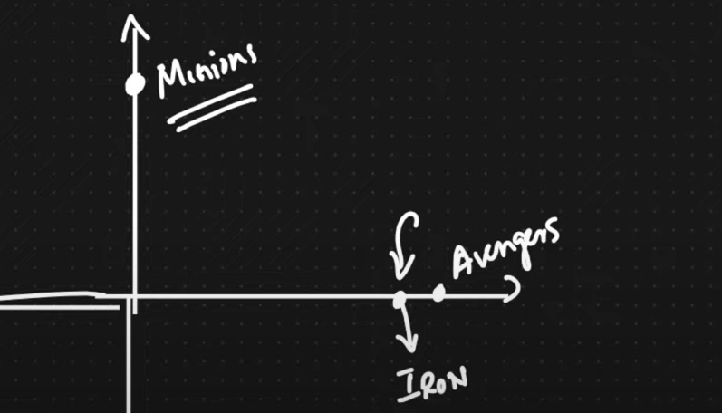

This is heavily used in **recommendation engine** here avenger and Iron man are similar, but Minions is different as they are making 90-degree angle between them.

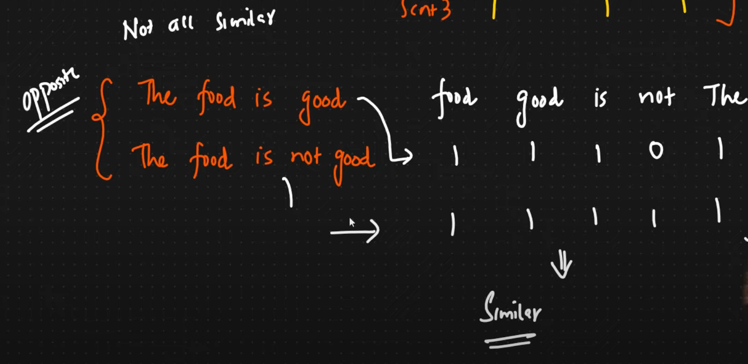

In the above example both the sentence or **documents are different like opposite** but the vector **looks similar** if we find cosine similarity that’s the main problem **semantic meaning is missing** like which words should I focus more that will be **fixed using TF-IDF.**

### Capturing semantic Information using Ngrams

* Bigrams (combination of two words)
* Trigram (Combination of three words)
* Ngrams (Combination of n words)

Apart from single feature we will be using combinations of features to understand semantic meaning of words.

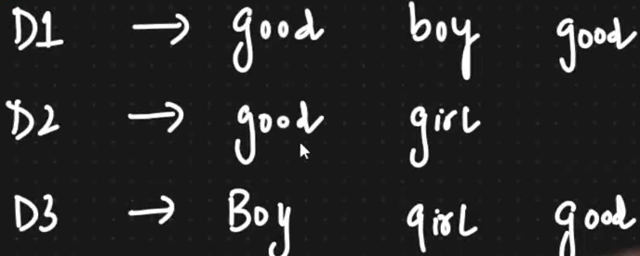

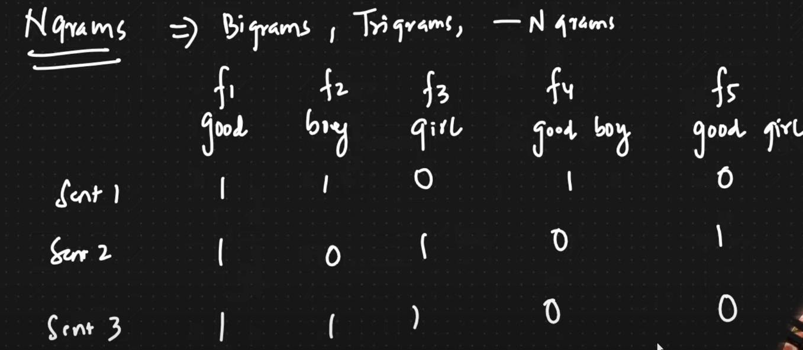

We are adding two more features f4 and f5 using **Bigrams**.

How many **Bigrams** will be possible for word **I love food**? **I love and** **love food** only two bigram I food can’t be possible.

How many **Trigram** will be possible for word **I am not feeling well**?

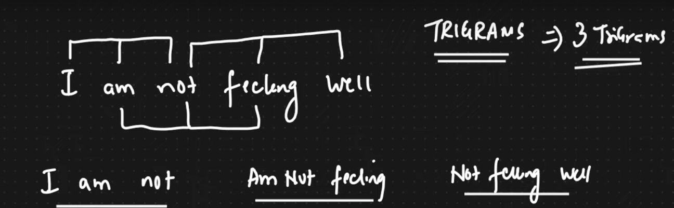

If we say combination of **Ngrams is (1,3)** then we will include single feature (unigram), Bigram and trigram 1 to 3. Say doc is I am feeling well my feature will be.

* f1 – I,
* f2 – am,
* f3- feeling,
* f4- well,
* f5-I am,
* f6-am feeling,
* f7-feeling well,
* f8-I am feeling,
* f9- am feeling well

### TF-IDF (Term Frequency - Inverse Document Frequency)

It has two important concept **Term Frequency** and Inverse **Document Frequency**. Here we are trying to solve the issue i.e. semantic meaning of the words to know which word we need to focus more on.

Whichever words are **rarely presen**t in the sentence we will give **more weightage**.

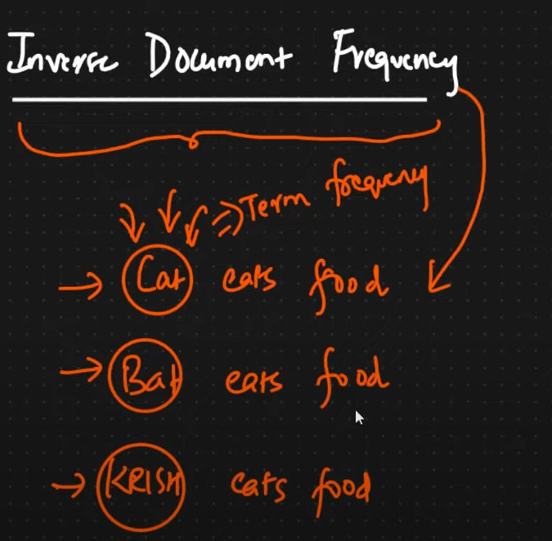

Here rare words are Cat, Bat and Krish rarely present in the sentences so we need to give more weightage.

* These **rare** words will be captured by **Term Frequency** which will have more weightage.
* **Common** words will get captured by **Inverse Document Frequency.**

When we combine both semantic meaning will be there.

**Term Frequency:**

No of repetition of word in sentence / No of words in sentence

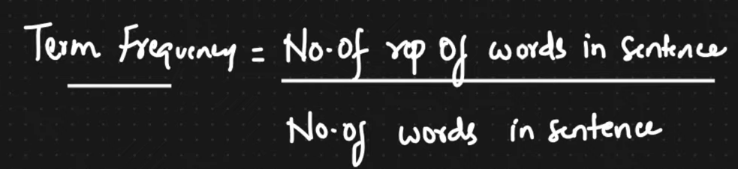

**Inverse Document Frequency:**

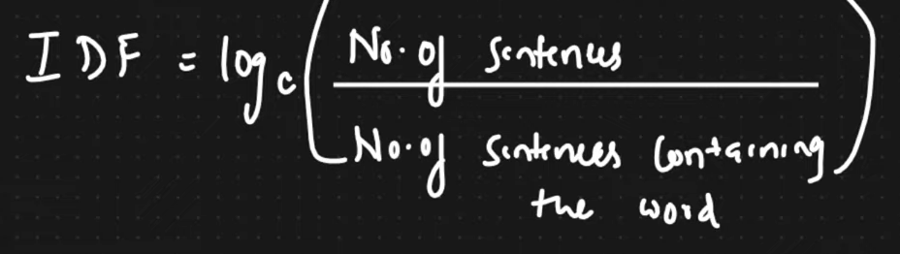

By multiplying both we will get TF-IDF

**Example**

***Find Term Frequency***

Here is my sentence.

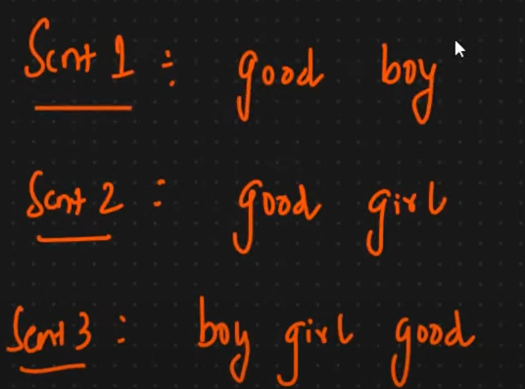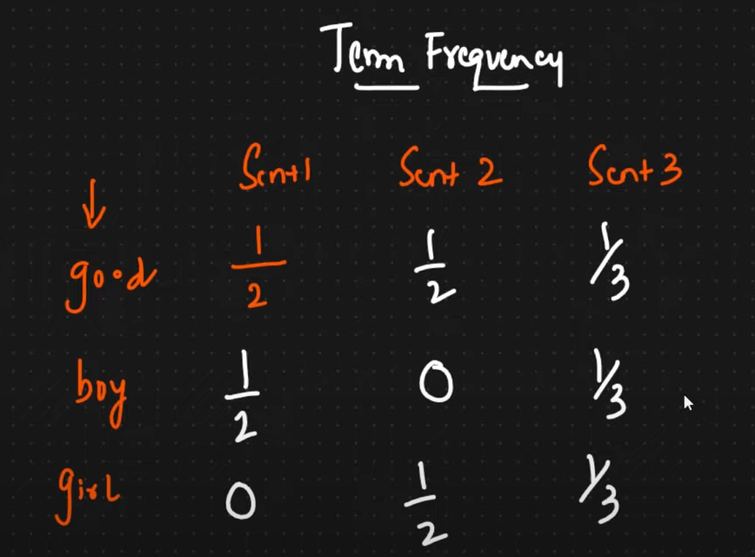

Here for word good in sentence 1 only one time is present and total word in sentence 1 is 2 hence TF is ½.

For boy in sentence-3 only one time is present total word in sentence is 3 so TF is 1/3.

***Find Inverse Document Frequency***

This gets computed for every sentence.

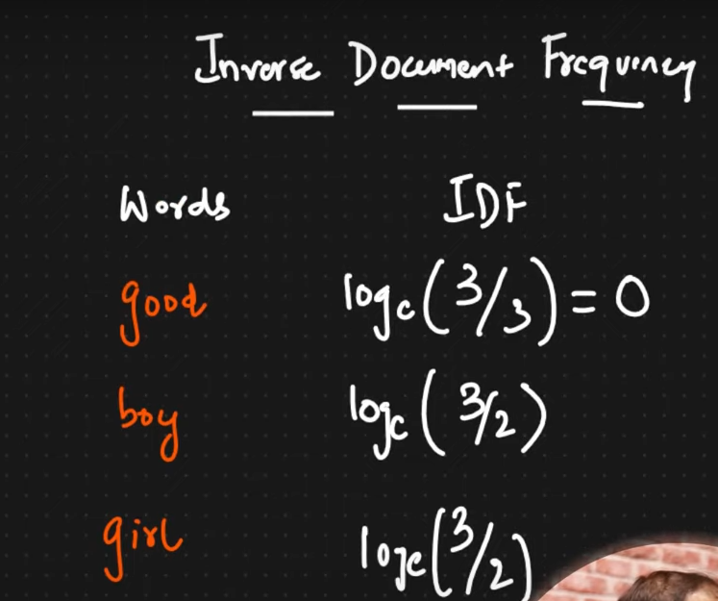

Here no of sentence is fixed that is 3 and good is appearing in all 3 sentences so good is common word and log (3/3) =0 so no weightage.

Similarly for word boy it is appearing only in sentences so log (3/2)

If we multiply both then we will get TF-IDF

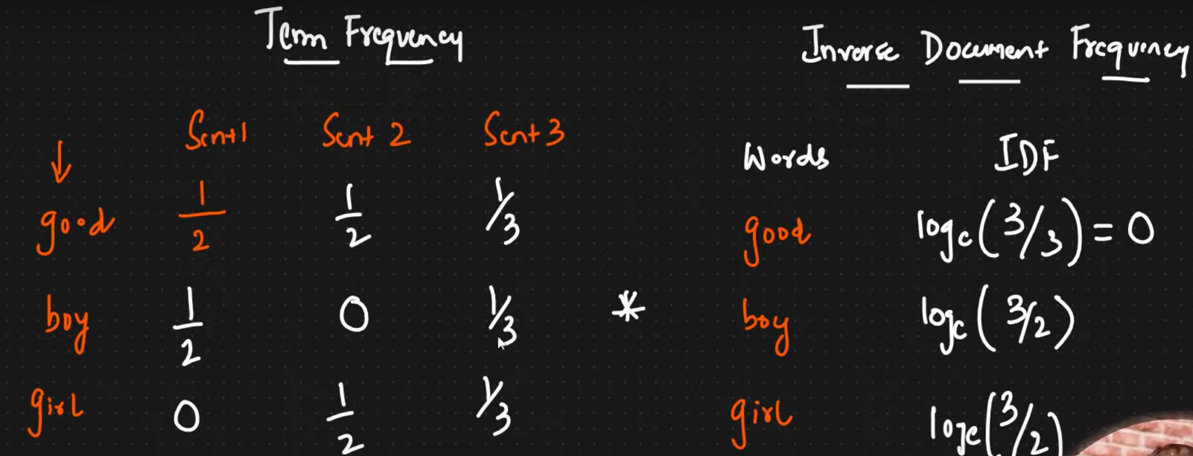

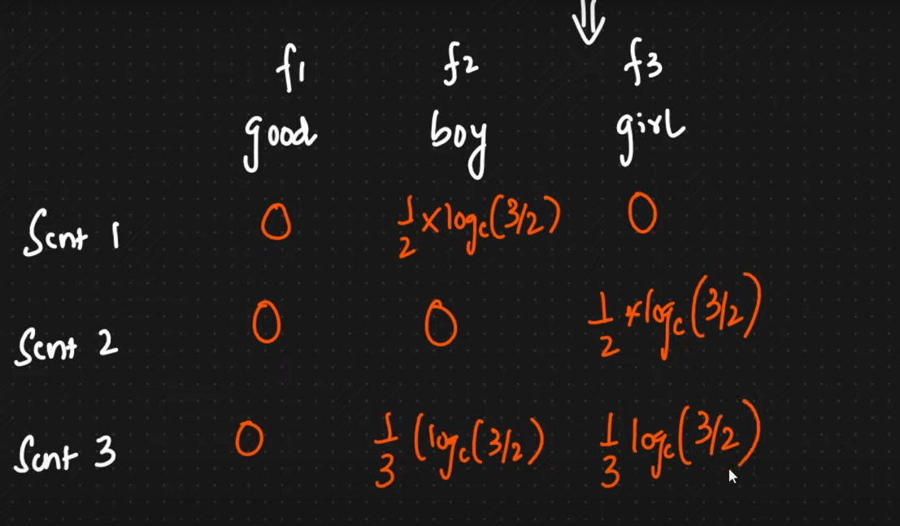

Now we will multiply TF and IDF in feature space like for good in sentence 1 we had ½ and from IDF it is 0 so it will be ½*0 =0

* Thus, we are removing or reducing weightage for common words and increasing weightage for rare word so some semantic meaning is captured.

**Advantage**

* Intuitive
* Word important is getting captured like semantic meaning.

**Disadvantage**

* Sparsity is still there for large data set though better than BOW.
* Out of Vocabulary is still there.